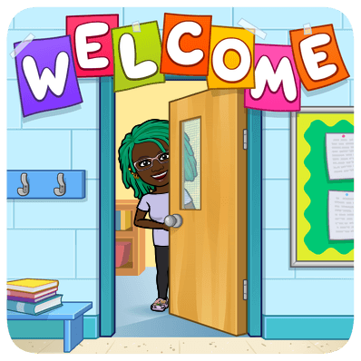

Dear Family,

My name is Mrs. Conner-Moton. I am the Reading Specialist at Bryan Hill Elementary. Your child is a student in our Individual Reading Support Plan reading groups.

I will meet with small groups of 4-5 students for 30 minutes each day. During this time, we focus on improving fluency by practicing vocabulary, word study, and comprehension through reading, and writing. The purpose of this intervention is to increase the ability to complete on level coursework and to give students an extra boost of what they are learning in class.

Growth in these areas can promote reading on grade level. Please encourage your student to participate in our intervention groups fully by: following directions, asking and answering questions about the topic, trying their best, and completing assignments.

Thank you for your time and support. If you have any questions, feel free to call me at 314-534-0370 or email me at grace.conner@slps.org. Please sign and detach the bottom of this letter, showing that you have received and read it.

Thank you,

Mrs. Conner-Moton

Reading Specialist

Bryan Hill Elementary School

Student Name: _________________________________________________________

Parent Signature: _______________________________________________________

____ I received and read the Individual Reading Success Plan orientation letter